Project Editing: Planning and Discussion

Current Feature Capabilities & Future Direction
Edit syncing is a known feature expansion planned loosely for Q2 2026.
Today, editing is supported only through downloaded AIP files. This capability is limited because files can’t be reuploaded to the SpecterX platform and changes are not synced.
Planning for feature expansion for MVP needs to allow sync changes at a minimum, from the SpecterX Viewer and ideally across supported opening applications.

Discussion - April 29th,
Attendees:
- Ido Bloch
- Guy
- Shahar
- Nimrod

Goal: How to achieve editing across both Google and Microsoft
- Need sync back after session close flow
- Need locking mechanism in other platforms opening file while editing is currently in session
  - User could open in read only while edits are in session
Approach
- Artem will begin in researching the trigger to understand when the user has closed the session and if changes were made
- Within Office online files are being saved in Sharepoint so trigger is from SP mediation storage
- We will still need to support editing through the SPX Viewer - WOPI isn’t viable
  - OnlyOffice is high cost
    - Shahar suspects how users/sessions will be calculated
    - Guy’s hypothetical cost/usage seems to assume license calculation is per user editing, not users Opening the file with the viewer
  - WebDov is another but still limited to Microsoft

Goals & Timelines:
- Artem estimates a week of dedicated research for Google Docs, Office Online and webdov Native Opening
  - Need to redesign the up session flows
  - Need to look for locking mechanism
  - Sync changes flow back
- Ihor will begin AIP file reupload flow as a parallel editing feature
- Decision still needed around providing the owner the ability to save changes or save to copy
  - Shahar suggests having the data owner dictate at send if the contributor changes should be saved to new copy or override existing
  - Loren will outline user workflows we’re aiming to support
    - Loren to work with Aik for frontend design
- Need customer feedback into the workflow needs. Shahar suggests:
  - Fireblocks
  - Bulwarx
- SPX Viewer /Only Office
  - We will pause research/efforts here until Guy is back

Discussion - April 15th, 2026
Attendees:
- Ido Bloch
- Guy
- Shahar

Clearification on the dubbed “co-authorship” feature in Microsoft
What is does not do:
When editing Microsoft Office files online (through SharePoint, OneDrive of Office Online), it is possible to “Open in Desktop” and continue editing the file in Office Desktop software (see picture)
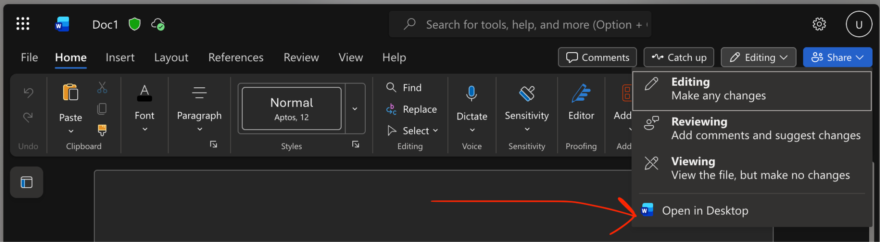

This capability is not available for files that have already been downloaded. This is a fact regardless if the file was downloaded through SpecterX or through MS Cloud app, and regardless of AIP protection being enabled or not.

The only way to have changes sync back from a locally opened file, is if this file was opened through the “Open in Desktop” button clicked in one of the cloud platforms.

What is does do:
It allows users the convenience of editing a cloud-hosted file in desktop software.
It allows desktop users (who opened the file through the cloud) to edit side-by-side with users editing in online Office.

Conclusions of Upcoming Steps for Editing in SpecterX
There are essentially 3 paths to introduce edits or changes to a file managed by SpecterX:
- Re-upload and overwrite
- Edit in our own online viewer/editor
- Edit in third-party cloud platforms (Microsoft “co-authorship” goes here)

In a bit more detail:
- Re-upload and overwrite
  - Can be identified through the same filename in the same folder
  - Can be identified through an AIP label marking the file
- Edit in our own online viewer/editor
  - For this we will integrate OnlyOffice, which should have easy-to-implement editing features
- Edit in third-party cloud platforms (Microsoft “co-authorship” goes here)
  - Office365 - We’ll allow users to edit in Office365 apps, and we’ll sync back changes to SpecterX, in a similar flow to “Re-upload and overwrite”. This includes:
    - OneDrive
    - SharePoint
    - Office Online Apps
    - “Open in Desktop”
  - Google Drive - We’ll allow users to edit in Google Drive, and we’ll sync back changes to SpecterX.

Managing Conflicting Incoming Changes
Once we’ll have editing working for all the cloud platforms, we can allow “live editing” / “co-editing” (the experience of several people editing at the same time) in each of the online editors separately (this include our own editor), we cannot allow this feature on multiple platforms at the same time.

That means that we’ll re-use the locking mechanism that will be implemented for the first phase (which won’t support co-editing), to lock out other platforms while the file is being edited on one.

Example 1:
- User A opens a file in the SpecterX Editor (powered by OnlyOffice)
- User B opens a file in the Google Drive
- User A makes changes to the file
- User B cannot make changes, as the file is locked
- User B refresh the page and sees more recent changes
- User A closes the SpecterX Editor
- User B refreshes the page again. Since User A is not editing anymore, User B now has editing privileges in Google Drive.

Example 2:
- User A opens a file in Office Online
- User B opens a file in the SpecterX Editor
- User B cannot make changes, as the file is locked
- User A makes can edit and make changes to the file
- User C opens a file in Office Online and clicks “Open in Desktop”
- User C can also makes changes, as both User A and User C are editing the Microsoft Cloud-hosted copy of the file

Discussion - April 13th, 2026

Attendees:
- Ido
- Loren

Progressive steps for dev:
- Wireframe the UI panes for upload duplication recognition in Workspaces & Send file back
  - Notify the owner
  - Allow sync changes by the data owner (via mail notification and ideally in the WebUI itself)
- Making technical decisions how editing is achieved
  - We will need to replace the viewer with confidence in the pricing and packaging strategy
  - We need to resolve plan of editing in Viewer AND editing in AIP
    - Co-authorship is intended to be supported in one but not both
    - This should also consider Nimrod/Shahar’s research and desire for editing to expand in AIP:
      - Note that testing for dynamic watermarking through AIP has been requested by Nimrod & Shahar
      - Note that Nimrod & Shahar have also researched co-authorship via AIP
  - Solidify technical plan to lock files when another user is editing

Action items::
- [Ticket is needed for Artem] - Create backend architecture for supporting few versions of the same file:
  - For allowing the owner to compare and choose if he would like to update his own file with the updated version
  - (Later) For allowing the owner to restore to an older version of the file
- [Ticket is needed for Aik] - Create Frontend design of the
  - Email notification to the file owner letting him know an updated version was uploaded
  - Compare page for allowing the owner to view/download both files and selecting which version they would like to have
- Research editing capabilities in AIP - so we can have a concrete plan to support it in Production (Ido Bloch - call with Shahar Band)

Discussion - March 24th, 2026
Attendees:
- Guy
- Ido
- Loren

How to approach comparing files:
- We would need a mechanism that looks at existing versions and incoming versions and allows the user to switch between the 2 - but not view both at the same time.
- As Google drive approaches this, we don’t need to highlight the specific changes – Google Drive highlights the entire text as new
- Also like Google Drive, we should recognize name (1) as duplicates

The Viewer costs:
- OnlyOffice Viewer will cost us at $22K for the year with a minimum of 250 users
- Guy would like to carry this cost over to the user – treating editing as an upper level tier
- Next step is to understand the cost at scale

The other option for cost considerations would be to look for an alternative
- Maybe our existing viewer could be utilized with updates and improvements

In parallel to editing through AIP and reupload flows – we need to

WebDov - this is an approach that would allow us to offer “open locally” to edit.
- Ido had tested this with encrypted files previously and it was supported
- Ido has a concern with this approach with Macs

Next steps here:
- Guy will look into pricing for OnlyOffice at scale
- We will try to have Shahar to discuss specifically for Co-authorship through AIP
  - In the meantime, Guy will try to take this and begin prototyping
- Loren will create tickets Aik to create frontend design and then Artem will take this for the design on the backend

Discussion - March 17th, 2026
Attendees:
- Ido
- Guy
- Artem
- Loren

Scope begins with reupload within the same workspace. This would require a clear distinction between Workspaces and Folders.
- Workspace will be the only space where files can added by users other than the owner
  - Files CAN be uploaded to a folder within a Workspaces
- Only owners can upload files to existing folders

Down the road, folders could be shared as Folders or Workspaces and Folders could be converted to a Workspace.

File lifecycle note – could there be a path to add an identifier or tracking element for non-AIP files. We would use this to properly identify ownership AND use this as a security feature in the future.

Versioning
- Bare minimum – the version the owner had and the version that will be overwritten
- We would need a UI for the owner to compare versions and make the decision to override OR save as new copy

Research/planning needed
- Mechanism for versioning support utilizing customer storage
  - Ido suggests possible Git mechanism for comparing versions
- Mapping out of user workflows for upload and multiple copy consolidation
  - Notification flow for owner and merge when multiple recipients have downloaded
- Locking AIP or reauthorship
  - Need to look at path to co-authorship with editing locally and Viewer
  - Constraint – if live editing will be supported, the other platform must be locked – we cant support live editing in both AIP and an online viewer

Progressive Plan
- Step 1 - v1.21:
  - Duplication by name will be recognized when owner is uploading a file of the same name to their My Files
  - Notification prompts to save new or use existing – no viewer for comparison
  - We would need version comparison – research needed here
    - Backend - How would we implement backend architecture to support versions for a file
    - Frontend - look for a library that allow to highlight changes
- Step 2:
  - Allow this in Workspace with the Owner of the workspace allowing decision to override or keep as copy - non encrypted files only

    - Notification flow to prompt owner to consolidate duplicates
- Step 3:
  - Allow workflow for Workspaces with SpecterX AIP encrypted files

Discussion - March 9th, 2026
Attendees:
- Guy
- Loren
- Bloch

Separating out the editing steps allow us to reach a better end case:
- Recognize the duplicate upload and replace my own file at upload “We recognize a file of the same name that YOU own - do you want to replace it or make a copy”? – (Specifically in the webUI?)
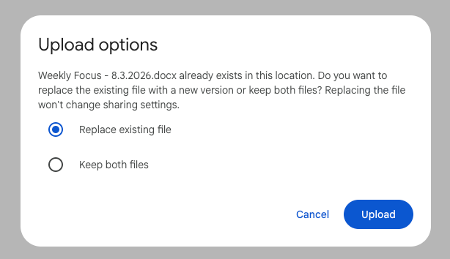

- Other peoples files – asking the actual owner for their decision? The owner needs to approve it.
  - This is workspaces
- Then do override vs copy
  - And if not the owner, get the permission to override
  - Could approach ownership transfer
- Then it is AIP file

Discussion Notes - March 4th, 2026
Attendees:
- Guy
- Loren
- Bloch
- Shahar

Approach of implementing OnlyOffice:
- OnlyOffice replaces WOPI+OfficeOnline
- Decision needed to lock the document while one user is editing
- This is a better option that iframing Sharepoint (Shahar’s suggestion) as Sharepoint isn’t intended for this
  - Clarification – when we are talking about Sharepoint as a viewer, we are talking about accessing OfficeOnline via Sharepoint

Considerations for Sharepoint Connector:
- Sharepoint Connector is currently set up for view only sharing.
  - We would need to consider that changes are made directly to the reference file
  - We need to consider conflict changes when changes are made in Sharepoint at the same time as changes are made by an editing recipient

Conclusion:
- OnlyOffice will be for the viewer replacement of Wopi
  - 1st step would simply be to replace the viewer event before editing
- Editing will be supported also AIP downloads
  - Resynced at upload
- Locking will be required to allow only 1 editor at the same time
- Both need to follow the same logic of owner vs uploader
  - Reuploading a protected file should produce the same results as editing via our online editor.

Discussion Notes - March 3, 2026
Attendees:
- Guy
- Loren

Guy wants to implement Only Office as the Viewer replacement. We will discuss the team call on March 4th.

Nimrod would like us to explore Co-Authoring as described in this Microsoft Documentation.

Discussion Notes - Feb 18th, 2026
Agenda: Discuss the initial approach and considerations to allow edit syncing.

Attendees:
- Shahar
- Ido Bloch
- Loren

Shahar initial perspective:
- Main goal of MVP to edit a document and sync the changes back
- To allow, we would need 2 main components:
  - 1 that makes sure 2 people can’t edit at the same time
  - Enable viewing in the applications we support:
    - 365
    - Google
    - Viewer

Versioning and counting copies of files:
- Versioning as industry knows it across Office and Google, won’t be approached in MVP, but syncing changes to a new copy or the existing copy will be needed

Technical considerations
- (Ido) This would require edited copies to override the copy in storage
  - Sync is more complex than PDF signature because it has to go through 2 services: WOPI & OOS
- Guy’s initial idea was to begin with SPX viewer only
- (Shahar) suggests we may want to replace our viewer with a singular view that can support editing of both PDFs and Office files
  - Shahar suggests we embed our own Sharepoint online as the opening mechanism. This is different from opening if 365 where it is shared directly to the users account
  - Suggesting this change because it would broaden the capabilities available for editing over existing viewer

Goals for MVP per this initial discussion:
- Implement edit syncing through online viewer
- Lock mechanisms to control concurrent editing - all the rest gets read only
  - OR choose one platform and allow live collaboration
  - Bloch things live collaboration might be easier to achieve rather than implementing locks
- When assigning collaborator roles, the sender would determine if edits should be synced back to the existing file or new copy
- Remedy for current editing AIP with this MVP:
  - Could turn off editing for AIP downloads
  - OR allow editing and only sync changes OR new copy under the original owner on reupload to SpecterX
  - OR change the way we handle AIP so that downloaded actually references a file still held by SPX

Next Steps:
- 1st step would be to research replacement of WOPI
- 2nd would be to decide if the approach is live collaboration or locking mechanism
  - Locking mechanism would only be needed if you allow edit syncing in multiple platforms.

